Catherine: Healed from Heavy Bleeding

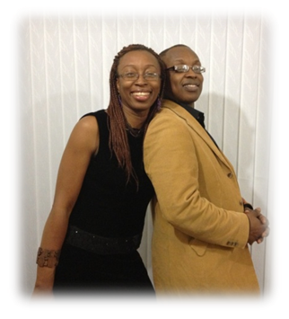
“I had been through a traumatic experience since 2007 when I started noticing intermittent heavy bleeding. When it happened I couldn’t walk and had excruciating pain. I was scheduled to have a blood transfusion. My brother who is a medical doctor was scared because my condition was so serious. I returned to Liverpool from Ghana and was admitted to hospital. The doctors found large fibroids in my womb. Soon after that another brother, Tom, came home one day after church with a gift for me from Paul Duckworth – a white handkerchief. He said “I stood in for you during the healing service and the man of God asked me to bring this to you. He said to tell you in a matter of days this situation will disappear”. I held on to the hand-kerchief. I came back again to Ghana in April 2013 and to date I have not experienced any bleeding. Today I am totally healed. I still keep the white handkerchief to remind me to give thanks for God’s faithfulness.”

The photo shows Catherine with her brother Tom who passed on to her the anointed handkerchief.

