Premature Birth

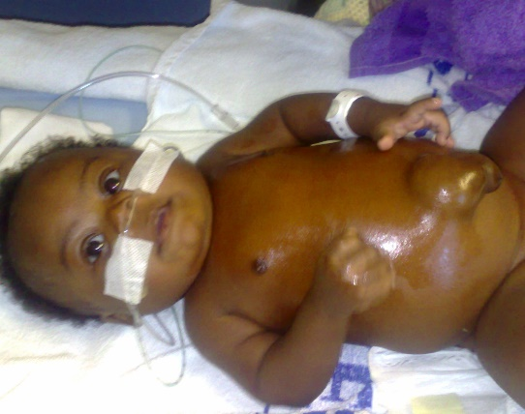
God never changes and His word always remains the same. That means that we can expect miracles. That is exactly what nine-month old Emmanuel received. He was in intensive care in hospital (pictured left and below left). I was asked to pray for him by his father, Ben.

Sarah (Emmanuel’s mum) gives this testimony:

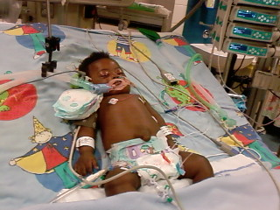
“Before our special boy Emmanuel was born, the devil has been attacking us through miscarriages but we thank God for his goodness. Emmanuel is very special to God and to us that’s why the devil been trying to kill him since he was born. Emmanuel was born 9 weeks early. Since birth it has been one thing or another. I could say that since November last year (2007) up to May this year (2008) the baby been in and out of hospital. We thank God because the last admission was really a battle because the baby was on a life support machine for 9 days. Thank you Paul for standing with us in prayer. Thank you so much Man of God. May God continue to use you. But I thank God because me (Sarah) and my husband Ben know that it is over.”

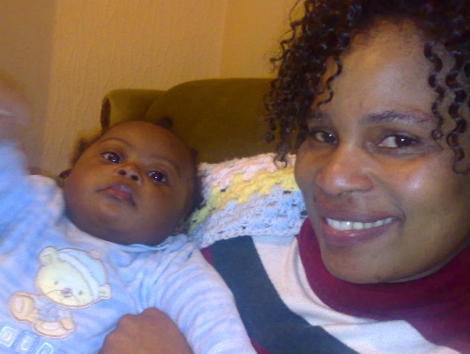
The photograph right shows Sarah at home with a healed baby Emmanuel. To God be all the glory. Amen and Amen.

